Half-RTA 1.9 – balance and game mechanics
Half-RTA has an inmap mod that changes game mechanics (i.e. creatures stats, heroes specializations, the way the skills work, etc.)

Skills and Abilities

Skills

Leadership
The Leadership of a Necromancer reduces enemy’s Morale by -1 / -2 / -3 (depending on the skill level).
This works only if a Necromancer plays for Necropolis.
Logistics
The player gets additional 2500 / 4500 / 5000 gold.
Runelore
Hero learns all the available runes irrespective of Runelore skill level.
Enlightenment
In addition to their normal effect Basic and Expert Enlightenment reduce a random hero stat by -1.
! At the same time Heroes initial stats are higher by +3. These changes are made to weaken Enlightenment.
Blood Rage
Rage Points absorb 50 / 55 / 60 / 70% of damage. || (it was 50 / 55 / 60 / 65%)
Gating
Reinforcements are 40 / 45 / 50 / 60% of the gated troops. || (it was 30 / 35 / 40 / 45%)
Counterstrike
Increases retaliation strike damage by 5 / 15 / 25 / 35%. || (it was 5 / 10 / 20 / 25%)
Artificer
Mini-artefacts power equals to [ 1.5 * spellpower – ( attack + defence ) ].
! While you create your mini-artifacts it is shown that you’ve got 1 knowledge. Real mini-artifacts power is calculated on the end of day four (just before the battle).

abilities

Archery – damage in ranged combat +25%. || (it was 20%)
Banish – the damage is [ 18 * ( hero_level + Summoning Magic mastery ) ]. || (10 * ( hero_level + Summoning Magic mastery ))
Banshee Howl – effect is -2 to morale and luck and -15% to initiative. || (-1 and -10%)
Benediction – +2 to morale, attack and defense and +15% to initiative. || (+1 and +10%)
Chilling Bones – in addition to its normal effect: hero gains +1 attack.
Corrupted Soil – the damage is [ hero_level * 4 ]. || (hero_level * 3)
Dark Ritual – in addition to its normal effect: hero gains +1 spellpower and knowledge.
Diplomacy – A stack of casters of your faction joins the hero's army. The quantity of casters is 10% of their basic quantity.
Distract – the penalty is 25%. || (15%)
Elven Luck – good luck strike deals 2.3 times more damage. || (2.25 times)
Estates – hero spends 15% less gold on buying artifacts.
! 15% of money spent on the artifact is returned after you buy the artifact at full price. This means that if you can’t pay the full price, you can’t buy it with a discount either.
Eternal Servitude – hitpoints of all creatures in hero's army are increased. The bonus is [ hero_level / 200 (%) ].
Evasion – damage by ranged attacks -25%. || (-20%)
Goblin Support – hero gains 50 Goblins and all the war machines to his army.
Haunted Mines – a stack of 20 Ghosts joins hero's army.
Hellfire – deals [ spellpower * 10 + 30 ] of Fire damage. || (10 * [spellpower + 1])
Lord of the Undead – in addition to its normal effect: the Undead Factory brings 25% more creatures. Also hero gains +1 knowledge.
Luck of the Barbarian – hero's army gains 15% of Magic proof irrespective of hero's luck. || (5% - a bug in the original game makes this ability give magic proof irrespective of hero’s luck)
Mana Burst – the damage is [ hero_level * 15 ]. || (hero_level * 10)
Mana Regeneration – before the combat hero steals 15% of enemy hero's mana.
Master of storms – the ATB value of the (first) target is multiplied by 0.6 || (0.7)
Mighty Shout – the hero's level is considered as being greater by +10 for Warcries. || (+5)
Navigation – creatures movement speed on board the ship is increased by +2.
Pathfinding – the battle will take place in the Stone Halls (no obstacles).
Recruitment – increases the number of creatures of level 1-3 available for hire by +15, +10, and +5 respectively.
Resourcefulness – hero receives a random minor artifact.
! If you unlearn this ability at Mentor, the artifact is taken back. If you sell the artifact before unlearning, you get a 2500 gold penalty.
Runic Armor – spellpower bonus for Arcane Armor is now +8. || (+4)
Runic Machines – increases initiative of all war machines by +4. || (+3)
Scouting – in addition to its normal effect: reduces the list of possible enemy heroes by 2.
Silent Stalker – in addition to its normal effect: reduces the list of possible enemy heroes by 2.
Snatch – the cost of visiting the Memory Mentor (or the Master) is reduced by 1000 gold.
! The gold is returned after you visit the Mentor at full price. This means that if you can’t pay the full price, you can’t visit him with a discount either.
Spoils of War – new artifacts become available in the shop (new artifacts replace present ones).
Swarming Gate – the chance is 20-45%. || (15-35%)
Tremors – the damage is [ 50 + spellpower * 5 ]. The stunning effect is a -0.2 ATB value reduction. || ([ 10 + spellpower * 5 ] and -0.1 ATB)
Warpath – the initiative of all enemy creatures is reduced by -1.

! Abilities that are helpful on the third day (like Logistics or Recruitment) work only if you start training your hero.
! A Skill Wheel mod is build into the map. There you can find actual descriptions of all the abilities.
Morale and Luck
A good luck strike deals 1.7 times more damage. || (it was twice more damage)
A bad luck strike deals 60% of damage. || (50%)
The ability Elven luck makes good luck strike deal 2.3 times more damage. || (2.25)
Good morale resets the creature's ATB value to 0.4 || (0.5)
Bad morale resets the ATB value to 0.6 || (0.5)

Spells

Changes in spell levels

Dark Magic:
1. Sorrow, Weakness, Vulnerability
2. Decay, Slow
3. Suffering, Confusion
4. Blindness, Vampirism
5. Puppet Master, Frenzy

Summoning Magic:
1. Fist of Wrath, Wasp Swarm, Fire Trap
2. Arcane Crystal, Raise Dead
3. Rhantom Forces, Earthquake, Blade Barrier
4. Summon Elementals, Summon Hive
5. Arcane Armour, Conjure Phoenix
Light Magic:
1. Regeneration, Divine Strength, Endurance
2. Deflect Missile, Haste
3. Cleansing, Righteous Might
4. Teleportation, Magic Immunity
5. Resurrection

Banned spells:
Divine Vengeance
Word of Light
Curse of the Netherworld
all the Adventure spells

changes in spell mechanics

destructive magic
Eldritch Arrow 96 + 8 * sp / 112 + 8 * sp / 128 + 8 * sp / 144 + 8 * sp || (48 + 8 * sp / 56 + 8 * sp / 64 + 8 * sp / 72 + 8 * sp)
Stone Spikes 48 + 8 * sp / 64 + 8 * sp / 80 + 8 * sp / 96 + 8 * sp || (24 + 8 * sp / 32 + 8 * sp / 40 + 8 * sp / 48 + 8 * sp)
Lightning Bolt 22 + 11 * sp / 28 + 14 * sp / 34 + 17 * sp / 40 + 20 * sp || (11 + 11 * sp / 14 + 14 * sp / 17 + 17 * sp / 20 + 20 * sp)
Ice Bolt 120 + 12 * sp / 144 + 12 * sp / 168 + 12 * sp / 192 + 12 * sp || (60 + 12 * sp / 72 + 12 * sp / 84 + 12 * sp / 96 + 12 * sp)
Fireball 22 + 11 * sp / 28 + 14 * sp / 34 + 17 * sp / 40 + 20 * sp || (11 + 11 * sp / 14 + 14 * sp / 17 + 17 * sp / 20 + 20 * sp)
Circle of Winter 120 + 12 * sp / 144 + 12 * sp / 168 + 12 * sp / 192 + 12 * sp || (60 + 12 * sp / 72 + 12 * sp / 84 + 12 * sp / 96 + 12 * sp)
Firewall no changes
Chain Lightning 20 + 10 * sp / 30 + 15 * sp / 40 + 20 * sp / 60 + 30 * sp || (10 + 10 * sp / 15 + 15 * sp / 20 + 20 * sp / 25 + 25 * sp)
Meteor Shower 18 + 9 * sp / 24 + 12 * sp / 30 + 15 * sp / 40 + 20 * sp || (9 + 9 * sp / 12 + 12 * sp / 15 + 15 * sp / 20 + 20 * sp)
Deep Freeze 20 + 10 * sp / 28 + 14 * sp / 30 + 15 * sp / 60 + 30 * sp || (10 + 10 * sp / 14 + 14 * sp / 15 + 15 * sp / 30 + 30 * sp)
Implosion 24 + 12 * sp / 34 + 17 * sp / 40 + 20 * sp / 80 + 40 * sp || (12 + 12 * sp / 17 + 17 * sp / 20 + 20 * sp / 40 + 40 * sp)
Armageddon 9 + 9 * sp / 12 + 12 * sp / 15 + 15 * sp / 20 + 20 * sp || (9 + 9 * sp / 12 + 12 * sp / 15 + 15 * sp / 30 + 30 * sp)

dark magic
Sorrow – lowers Morale and Luck by -2 / -3 / -4 / -5 || (-1 / -2 / -3 / -4)
Weakness – lowers the difference between maximal and minimal damage to 40 / 40 / 20 / 0% || (50 / 35 / 20 / 0%)
Vulnerability – lowers defence by -4 / -4 / -5 / -6 || (-3 / -4 / -5 / -6)
Slow – lowers Initiative by 20 / 20 / 30 / 40% || (25 / 30 / 35 / 40%)
Suffering – lowers attack by -6 / -6 / -9 / -12 || (-3 / -6 / -9 / -12)
Confusion affects 60 / 60 / 80 / 100% units in target stack || (50 / 70 / 90 / 100%)
Blindness duration is 0.1 * sp / 0.15 * sp / 0.2 * sp / 0.25 * sp || (0.15 * sp / 0.2 * sp / 0.25 * sp / 0.25 * sp)
Puppet Master duration is 0.1 * sp / 0.15 * sp / 0.2 * sp / 0.25 * sp || (0.15 * sp / 0.2 * sp / 0.25 * sp / 0.25 * sp)
and Initiative of target stack is multiplied by 0.015 * sp / 0.02 * sp / 0.025 * sp / 0.3 * sp || (0.01 * sp / 0.03 * sp / 0.03 * sp / 0.03 * sp)

Light magic
Divine Strength – increases the difference between maximal and minimal damage to 40 / 40 / 20 / 0% || (50 / 35 / 20 / 0%)
Endurance – increases defence by 6 / 6 / 8 / 12 || (3 / 6 / 9 / 12)
Haste – increases Initiative by 15 / 15 / 20 / 30% || (10 / 20 / 30 / 40%)
Deflect Missile – lowers damage inflicted by ranged attacks by 40 / 40 / 55 / 70% || (25 / 40 / 55 / 70%)
Cleansing – dispels with basic chance 60 / 60 / 80 / 100% || (40 / 60 / 80 / 100%)
spell costs 12 mana and 24 mana for mass cast. || (10 and 20)
Righteous Might – increases attack by 6 / 6 / 9 / 12 || (3 / 6 / 9 / 12)

summoning magic
Fist of Wrath – the damage is 40 + 4 * sp / 60 + 6 * sp / 80 + 8 * sp / 100 + 10 * sp || (20 + 4 * sp / 30 + 6 * sp / 40 + 8 * sp / 50 + 10 * sp)
Wasp Swarm – the damage is 20 + 2 * sp / 40 + 4 * sp / 60 + 6 * sp / 80 + 8 * sp || (10 + 2 * sp / 20 + 4 * sp / 30 + 6 * sp / 40 + 8 * sp)
spell costs 4 mana || (5 mana)
Blade Barrier – hit points are 40 + 8 * sp / 60 + 10 * sp / 80 + 12 * sp / 100 + 15 * sp || (20 + 5 * sp / 40 + 8 * sp / 60 + 10 * sp / 96 + 12 * sp)
Summon Hive – hit points are 80 / 120 / 160 / 200 || (40 / 60 / 80 / 100)
Initiative of the hive is 8 + 0.25 * sp / 9 + 0.25 * sp / 10 + 0.25 * sp / 11 + 0.25 * sp || (2 + 0.25 * sp / 5 + 0.25 * sp / 5 + 0.25 * sp / 10 + 0.25 * sp)

runes
Rune of Dragonform grants 75% magic proof and is now 4th level || (50% and 5th level)
Rune of Resurrection now has 5th level || (4th)

warcries
Call of Blood – grants [ 12 * hero_level ] rage points || (10 * hero_level)
Ralling Cry – increases Morale by +1 for every 6 hero levels || (1 for 8 levels)
effect lasts for 4 turnes || (3 turnes)
Battlecry – increases creatures movement speed by +2 on level 25+ (level 25 can be emulated by Mighty Shout), otherwise it gives +1 speed as usual.
Horde’s Anger – damage is equal to 90% of the number of creatures in hero’s army. || (100%)

details about the third set of spells

There’s a 25% chance of getting the third set of spells available to your hero.
If you get the third set of spells, your opponent gets it, too (but not the same spells, of course).
If the 25% chance triggers, you can get:
Dungeon: Dark – 75% chance, Light – 25%
Fortress: Summoning – 100%, no Dark Magic available for Fortress
Haven: Destructive – 50%, Summoning – 50%
Inferno: Summoning – 100%, no Light
Necropolis: Light – 100%, no Destructive
Sylvan: Summoning – 100%, no Dark
Academy has only one profiling magic – Summoning. As a second magic you can get any other magic school. As a result Academy cannot get the third set of spells, ( it has Library spells instead).
Academy chances for the second magic: Light – 50%, Destructive – 30%, Dark – 20%.
In case the 25%-chanse triggers for Stronghold, you get 2 warcries of level one (not just one warcry)
Heroes
Specializations of some heroes have been changed. Besides, some company heroes were added.

company heroes

Academy
Cyrus – hero learns enemy hero's spells (only those that he can learn).
Basic skills: Basic Enlightenment, Arcane Intuition
Maahir – hero receives additional 15 units of each resource for creating mini-artifacts.
Basik skills: Expert Artificer
Zehir – every time a friendly stack dies, a group of elementals enters combat at the hero's side. In addition, Summon Elementals and Summon Phoenix spells cast by the hero are stronger by [ hero_level / 4 ].
Basic skills: Basiс Summoning Magic, Master of Conjuration

Dungeon
Raelag – initiative of all creatures in hero's army is increased and initiative of all enemy creatures is decreased by [ 1% * hero_level / 3 ].
Basiс skills: Basic Irresistable Magic
Shadya – damage suffered from distant attacks is reduced. Damage reduction is [ 5% + 1% * hero_level ].
Basic Skills: Basic Defence, Evasion
Ylaya – hero learns all the spells of level 1-3.
Basiс skills: Basic Sorcery, Empowered Spells

Fortress
King Tolghar – all creatures in hero's army have 'Rune of Thunderclap' effect permanently active (refreshes at the start of creature turn). Also hero cannot learn runes level 4-5.
Basic skills: Advanced Runelore, Greater Rune
Rolf – hero randomly gets: 2 minor artifacts or 1 major or 1 relic or 10 000 gold.
Basic skills: Advanced Runelore, Basic Luck
Wulfstan – Berserkers and Battleragers in hero's army gain +2 to their speed and Initiative.
Basic skills: Basic Attack, Battle Frenzy

Haven
Godric – The Benediction effect is 1.5 times stronger. Mana used for casting Light Magic spells are reduced by 1.
Basic skills: Basic Light Magic, Benediction
Isabel – all creatures in hero's army get a Bless effect for the whole combat.
Basic skills: Basic Counterstrike
Nicolai – hero has a [ hero_level * 1% ] discount for troop training in Haeven towns. Also hero contributes 250 gold pieces in kingdom treasury per day.
Basic skills: Expert Counterstrike
Valeria – before the battle hero steals 30% of enemy hero's mana.
Basic skills: Advanced Sorcery

Inferno
Agrael – hero steals all enemy hero's minor artifacts.
Basic skills: Advanced Luck
Orlando – The Initiative of all creatures in hero's army is increased by [ hero_level * 0.4% ].
Basic skills: Basic War Machines
Sovereign – Arch Devils and Arch Demons gain +60 hitpoints.
Basic skills: Basic Defence, Vitality

Necropolis
Arantir – the Hero can summon a mysterious creature upon the battlefield to fight on his side. The creature's power depends on the Hero's level. If this creature dies, the Hero will lose all his Mana points.
Basic skills: Basic Summoning Magic, Basic Dark Magic
Markal – the Undead Factory brings 50% more creatures.
Basic skills: Advanced Leadership

Stronghold
Gotai – All warcries cost less mana and grant more rage points depending on the hero's level. The cost of all Warcries is decreased by [ 1 + hero's_level / 22 ]. The Rage bonus from the Warcry is increased by [ hero_level * 1 ].
Basic skills: Advanced Blood Rage, Basic Shout
Kujin – If any demonic troops are present in combat, creatures in hero's army gain Demonic Rage more quickly. Every time Rage Points are gained, the amount is increased by [ hero_level / 2 ].
Basic skills: Basic Enlightenment, Memory of Our Blood
Quroq – all Earth Daughters and Sky Daughters in hero's army can cast any spells of level 1-2 with Basic mastery.
Basic skills: Basic Leadership, Basic Attack

Sylvan
Alaron – hero can choose 4 favored enemies.
Basic skills: Ultimate Avenger
Spectre – Hero can see the whole map. (To activate this ability you need to visit the level-up building. As you visit it for the first time your hero doesn’t start training so that you could see the map first. However, after the map is revealed you cannot start training any other hero).
Basic skills: Expert Avenger
Findan – at the start of the battle all Sylvan shooters in hero's army make a shot at the weakest (the lowest level) enemy stack. If several stacks have the same level, the last in the army list is targeted. The inflicted damage depends on the hero's level. The archers and druids inflict [ 20% + hero_level * 2% ] of their regular damage.
Basic skills: Basic Leadership

changed standard heroes

Academy
Galib ↑ – The chance of redirecting a spell to an enemy stack is [ 60% + 2% * hero_level ] || (it was 40% + 2% * hero_level )
Faiz ↑ – the Vulnerability spell inflicts [ hero_level * 7 ] damage. || (10 * ( hero_level / 3 ))
Nur ↑ – restores [ hero_level / 2 ] mana points before each action. || ( hero_level / 3 )
Razzak↓ – standard starting army; no Haste spell at the start.

Fortress
Helmar ↓ – each time the hero casts a light magic spell on a friendly creature, there is a [ hero_level * 3% ] chance that the Righteous Might spell will be cast freely upon the affected unit. || (20% + hero_level * 3%)
Inga ↑ – with each level-up, the hero can learn one more Runic Spell with a chance of 30%. || (25%)
Svea ↑ – hero can learn empowered lightning spells. Basic skills are changed: Basic Destructive Magic, Basiс Sorcery
|| (it was Master of Storms instead of Sorcery)

Haven
Dougal ↓– standard starting army.
Аксель ↑ – Рыцарский разбег наносит на [ 10% + ур._героя * 1,5% ] больше урона; Надзор наносит на [ 2% * ур._героя ] больше урона
|| ( 10% + ур._героя * 1%; Надзор – 1% * ур._героя )
Rutger ↑ – combat movement speed of all creatures in hero's army is incresed by +1.

Inferno
Deleb ↑– spellpower of ballista fireball increases by [ -2 + hero_level / 4 ]. || ( -2 + hero_level / 5 )
Grok ↑– in addition to his usual ability: combat movement speed of all creatures in hero army is incresed by +1.

Necropolis
Deirdre ↑ – Banshee Howl reduces Luck and Morale by -3. Initiative is reduced by 15%. || (+2 and 10%)
Kaspar ↑ – in addition to his usual ability: hero is given the Ring of Machine Affinity before the battle, if he does not already have it. Now the hero has Runic Machines ability instead of First Aid at start.
Vladimir ↑ – The Raise Dead spell has increased effect. The spellpower of this spell is increased by [ 1 + hero_level / 3 ]. || ( hero_level / 5 )

Stronghold
Garuna ↓ – Each killed enemy troop (summoned troops considered, too) increase the Attack of all the creatures in hero's army by [ hero_level / 7 ]. || (hero_level / 6 )
Haggash ↓ – there's no more ATB bonus for Centaurs.
Kilghan ↑ – A stack of 150 goblins join hero's army.
Shak’Karukat ↑ – Wyverns, Foul Wyverns and Paokais in hero's army gain additional [ 10 + hero_level * 2 ] hit points. || ( -1 + hero_level * 2 )
Urghat ↑ – at the beginning of the combat increases the ATB value of his troops and decreases ATB value of enemy’s army.

Sylvan
Anwen ↓ – all Sylvan creatures under hero's command inflict [ hero_level * 1.5% ] more damage to favored enemy. || ( hero_level * 2% )
Dirael ↑ – Wasp Swarm spell is more effective depending on hero level. Damage is increased by [ hero_level * 10% ]. Base reduction of ATB value (0.2 / 0.4 / 0.6) is increased by [ hero_level * 1% ]. || (damage is increased by [ hero_level * 5 ] and reduction of ATB value is multiplied by [ 1 + 0.02 * hero_level / 3 ])
Vinrael ↑ – Hero gets one more free level up at the level up building. I.e. hero gets 18 levels free of charge and can reach level 22.
Wyngaal ↓ – Creatures in hero's army get a [ hero_level * 0.6% ] bonus to their initiative at the start of the combat. || ( hero_level * 1% )

Some heroes are banned in some match-ups:
Inferno – Dungeon: no Marbas
Inferno – Necropolis: no Marbas
Necropolis – Necropolis: no Zoltan
Stronghold – Strondhold: no Urghat
! Also, company heroes and Wyngaal cannot be hired in Tavern.

Artifacts
Windstrider Boots, Ring of Banishment and Ring of Machine Affinity are now Major artifacts.
Shackles of the Last Man now decrease movement speed of all enemy creatures by 1.

prices for some artifacts are changed:

Minor artifacts
Armor of Valor – 7000
Bearhide Wraps – 5000
Cloak of Sylanna – 6000
Crown of Leadership – 4500
Four Leaf Clover – 4500
Necklace of the Lion – 4500
Tarot Deck – 7000

Major Artifacts
Cape of the Lion's Mane – 9000
Cursed Ring – 12000
Dragon Flame Tongue – 15000
Dwarven Smithy Hammer – 10000
Golden Horseshoe – 9000
Necklace of the Bloody Claw – 10000
Ring of Banishment – 8000
Ring of the Broken Will – 12000
Ring Of Celerity – 11000
Ring of Lightning Protection – 5000
Ring of Machine Affinity – 10000
Ring of Vitality – 10000
Shield of Crystal Ice – 10000
Windstrider Boots – 10000
Relics
Cloak of Death's Shadow – 24000
Cuirass of the Dwarven Kings – 15000
Greaves of the Dwarven Kings – 15000
Helm of the Dwarven Kings – 15000
Lion Crown – 18000
Pendant of Mastery – 15000
Ring of Sar-Issus – 15000
Sandals of the Blessed – 18000
Sandro's Cloak – 16000
Shackles of the Last Man – 20000
Shield of the Dwarven Kings – 15000
Staff of Sar-Issus – 15000
Unicorn Horn Bow – 18000

Tome of Destruction Magic – 25000
Tome of Light Magic – 25000
Tome of Dark Magic – 25000
Tome of Summoning Magic – 15000

Banned artifacts:
Ring of Speed
Rune of Flame
All the artifacts that enhance Destruction Magic spells
Magic Scrolls
Wands

Also, all the artifact that has no use on the map are banned.

Army bonuses for unequal matches
In some match-ups one of the factions takes a bonus. This bonus is some extra army (and gold so that you could buy it). In this table additional army is shown in %:

Faction ta- Its opponent Bonus
king bonus

Academy Fortress : 5%
Academy Stronghold : 5%
Dungeon Fortress : 5%
Dungeon Stronghold : 5%
Fortress Inferno : 10%
Fortress Necropolis : 15%
Fortress Stronghold : 5%
Fortress Sylvan : 5%
Haven Fortress : 5%
Haven Inferno : 10% + 4 знания
Haven Dungeon : 5%
Haven Necropolis : 5%
Haven Stronghold : 5%
Necropolis Academy : 5%
Necropolis Dungeon : 5%
Necropolis Inferno : 5%
Necropolis Sylvan : 5%
Stronghold Necropolis : 5%
Sylvan Stronghold : 5%

! You can also see this list by right click on the Signpost in the Starting Area.

War Machines
Hit Points of Ballista are increased to 700 (250). So, if your hero got Expert War Machines and ability Ballista, it has 2000 HP (1100) .
Hit Points of First Aid Tent are increased to 500 (100). Expert War Mashines + First Aid ability gives 1600 HP (800).
The number of “shots” of First Aid Tent is increased to 10. (3)

↓Creatures

Creatures

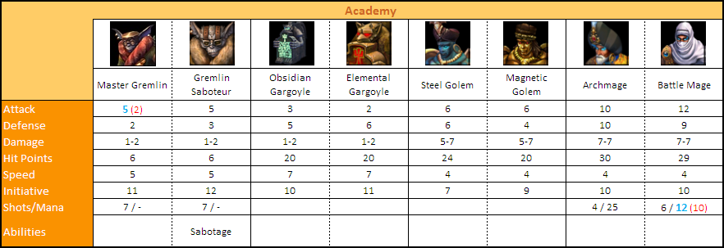

Sabotage – multiplier is two times weaker (it was 10 and now it's 5).

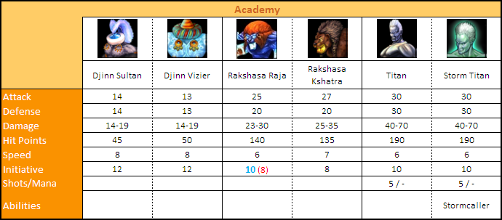
Stormcaller – the shooting penalty is 3% for every Storm Titan, the effect lasts for 5 turns. || (it was 1% and 3 turns)

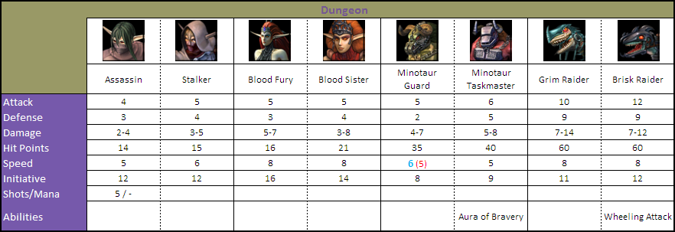
Aura of Bravery – minimum Morale for creature and all adjanced friendly stacks is +3. || (+1)
Wheeling Attack – the ability deals 75% of creature's normal damage. || (25%)

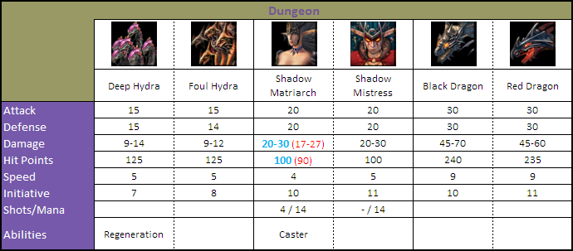
Regeneration – creature restores its health by 70-100 hit points each turn. || (30-50)
Caster (Shadow Matriarch) – the Divine Strength spell with Advanced mastery level is now available for the creature.

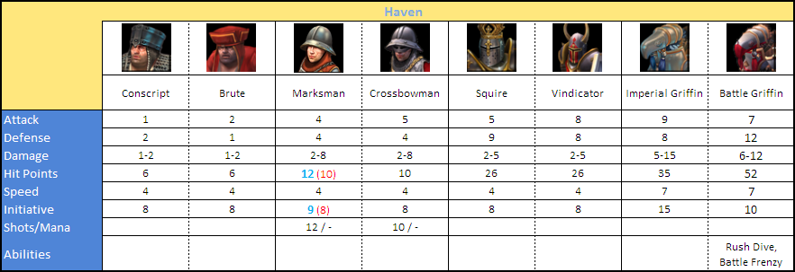
Rush Dive – creature deals 100% of its normal damage; the ability can be used as many times as you want. || (75% and once per combat)
Battle Frenzy – every next retaliation strike is 1.8 times more powerful. || (1.5 times)

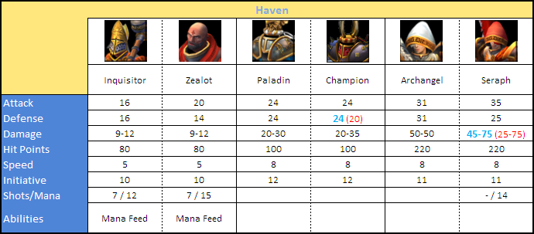
Mana Feed – the ability is given to Inquisitirs and Zealots

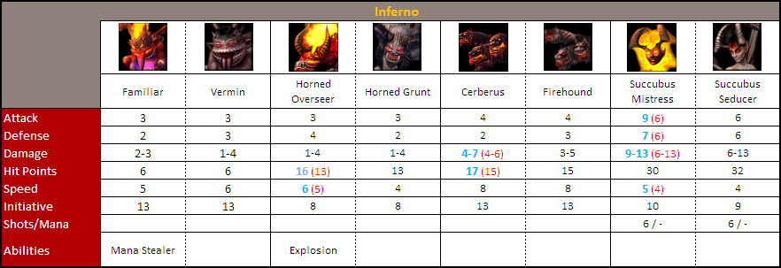
Mana stealer – steals 0.2 mana for every creature in the stack. || (0.25)
Explosion – deals [ 50 + 10 * creature_sp ] damage; the ability can be used as many times as you want. ( [ 9 + 9 * creature_sp ] and once per combat)

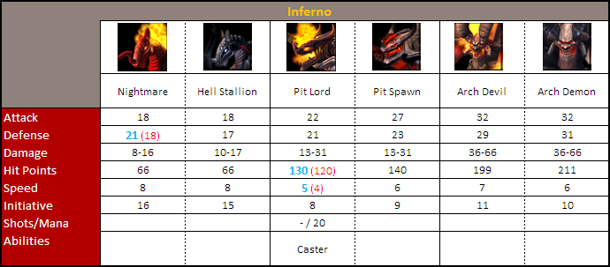
Caster – Fireball and Meteor Shower are casted on Advanced level. || (Basic level)

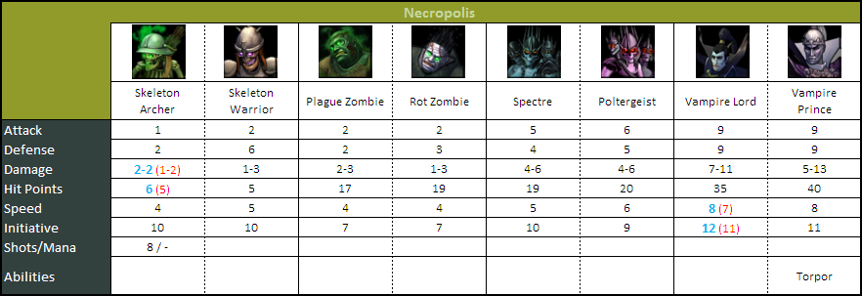
Torpor – the chance to put an enemy into slumber is 1.5 times smaller.

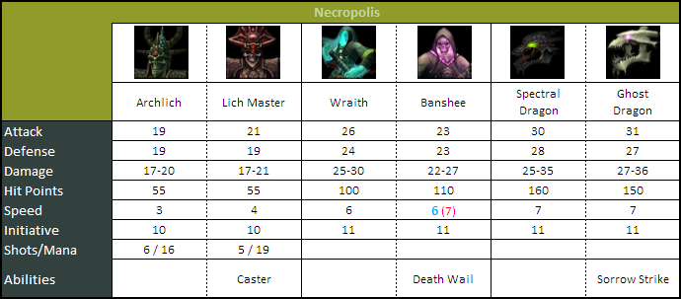
Caster – the Wasp Swarm spell with Basic mastery level is added.
Death Wail – basic damage is ([ 15 - target's morale ] * 2) || ((10 - target's morale) * 2)
Sorrow Strike – Sorrow is casted on Advanced mastery level || (Expert level)
! As the Sorrow spell was strengthened, its mastery level for Sorrow Strike was lowered. So, the ability effect is still -4 Luck and Morale.

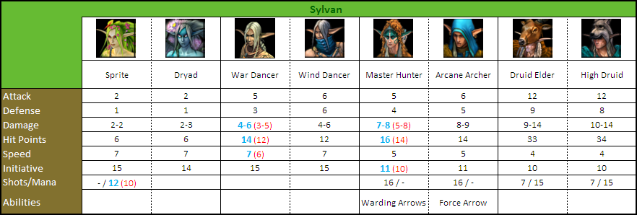
Warding Arrows – the chance to trigger is 1.5 times higher.
Force Arrow – ranged attack ignores 40% of the target's Defense || (50%)

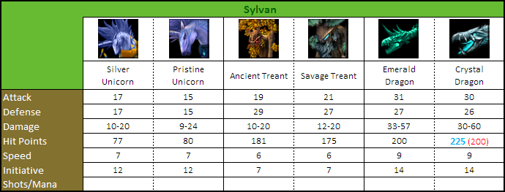

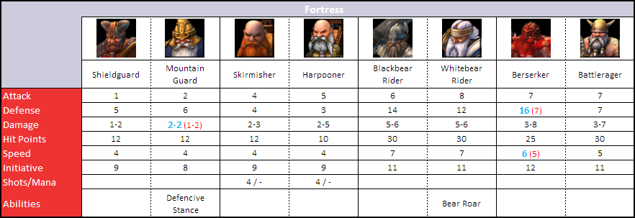
Defencive Stance – the creature has a +15 bonus to defence until it moves. || (+5)
Медвежий рев – the chance to frighten small creature is 1.5 times higher then big creature || (2 times)

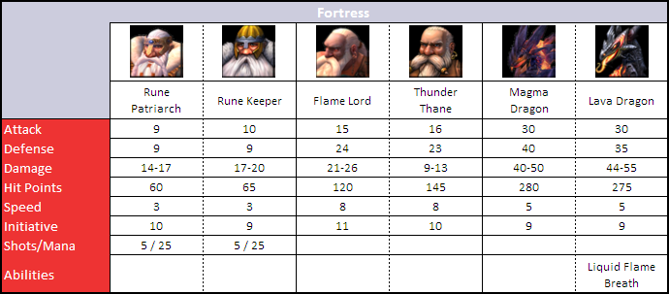
Liquid Flame Breath – the damage is 15 per every Lava Dragon. || (10)

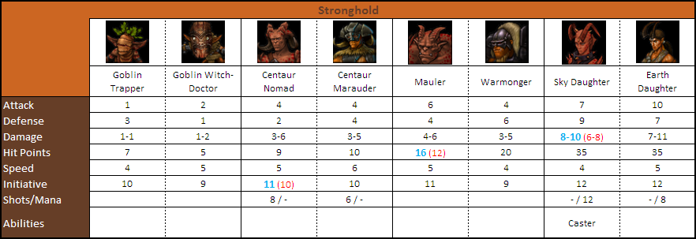
Колдун (Дочери неба) – on the 1st level of rage creature gains заклинание Deflect Missile spell,
on the 2nd level of rage – Teleportation and Meteor Shower,
on the 3rd level of rage – Arcane Armour and Deep Freeze on the third level of rage;
all the spells are casted on the Advanced mastery level.

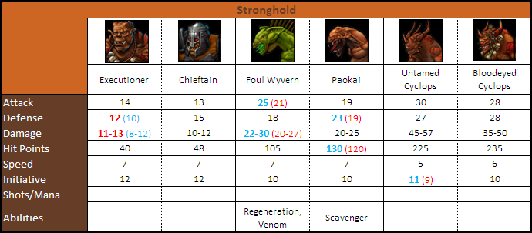
Regeneration – creature restores its health by 70-100 hit points each turn. || (30-50)
Venom – deals 7 damage for every Wyvern || (5)
Scaveneger – рealth gained is equal to 25% of the dead stack's Hit Points. || (20%)

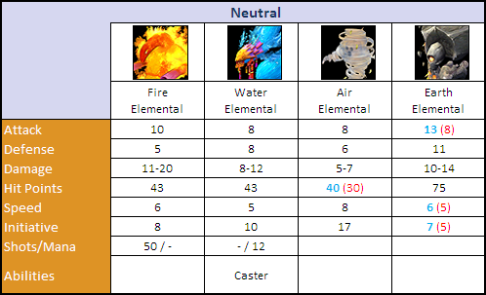
Caster – the Deep Freeze spell with Basic mastery level is added.

